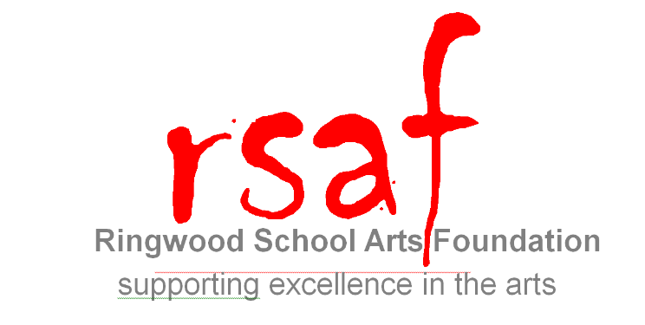

Friends of Ringwood School Arts Foundation

I enclose my contribution of £……….............

I have completed my payment online at www.rsaf.co.uk/become_a_friend

I would like to support the Ringwood School Arts Foundation through the coming year (until September 2018).

Please complete this form and return, together with your cheque, made payable to RSAF, to Mrs. N. Frullo, Ringwood School, Parsonage Barn Lane, Ringwood, BH24 1SE. Bank Details for Bank Transfers are detailed below.

Should you wish to contribute more than the minimum £10 it will be gratefully received.

If you would like a receipt please tick the box.

I, (name)............................................................................................................................................................................

of (address)........................................................................................................................................................................

.............................................................................................................. (Post Code) ………………………………………………

email address .................................................................

enclose £10/…………..……..…..* as my donation to Ringwood School Arts Foundation.

From time to time we may publish the names of people who have donated to the Trust.
Please indicate by crossing the box if you DO NOT want your name to be published

I do/do not* pay income tax at the standard rate (for the purpose of Gift Aid). I understand that this gift will be used solely by the Ringwood School Arts Foundation to develop arts projects, to support students and promote excellence.
*please delete as appropriate

Signed: ................................................ Date: ....................

If you wish to set up an annual Standing Order or make a donation via online banking please use your surname as a reference and please still complete this form for Gift Aid purposes.

Sort Code – 30-84-87
Account Number - 25846260

